

Experiment No. 3

Title: Implementation of Stemming of Text using different stemming modules in NLTK
Batch: NLP–1 Experiment No.: 03

Roll No.: 16010422234 Name: Chandana Galgali
______________________________________________________________________________

Aim of the Experiment: To implement stemming of Text using different stemming modules in NLTK
______________________________________________________________________________

Program/Steps:
- Apply Porter Stemmer, Snowball Stemmer, Lancaster Stemmer and Regexp Stemmer to a large corpus of Text.
- Write down the observations about differences in the working of each of the Stemmer by analyzing the result obtained after applying each Stemmer on large corpus of text

import sys
import subprocess
import os
import re
from collections import Counter, defaultdict

# --- Helper: install missing packages ---
def ensure_pkg(pkg_name: str):
try:
__import__(pkg_name)
except ImportError:
subprocess.check_call([sys.executable, "-m", "pip", "install", pkg_name])
__import__(pkg_name)

ensure_pkg("nltk")
ensure_pkg("pandas")

import nltk
import pandas as pd

# --- Step 1: Download required NLTK resources ---
def ensure_nltk_data():
resources = [
("corpora", "gutenberg"),
("corpora", "brown"),
("corpora", "reuters"),
("corpora", "stopwords"),
]
for rtype, name in resources:
try:
nltk.data.find(f"{rtype}/{name}")
except LookupError:
nltk.download(name)

ensure_nltk_data()

from nltk.corpus import gutenberg, brown, reuters, stopwords
from nltk.stem import PorterStemmer, SnowballStemmer, LancasterStemmer, RegexpStemmer

# --- Step 2: Build a large corpus (Gutenberg + Brown + Reuters) ---
def build_large_corpus_text() -> str:
texts = []
# Gutenberg
for fid in gutenberg.fileids():
texts.append(gutenberg.raw(fid))
# Brown (join words per category)
for cat in brown.categories():
words = brown.words(categories=cat)
texts.append(" ".join(words))
# Reuters (join words per file id)
for fid in reuters.fileids():
words = reuters.words(fid)
texts.append(" ".join(words))
return "\n".join(texts)

# --- Step 3: Preprocess (lowercase, alphabetic tokens, remove stopwords) ---
def preprocess(text: str):
# simple regex tokenizer: keep only alphabetic sequences
tokens = re.findall(r"[A-Za-z]+", text.lower())
sw = set(stopwords.words("english"))
tokens = [t for t in tokens if t not in sw and len(t) > 2]
return tokens

# --- Step 4: Apply stemmers ---
def stem_with_all(tokens):
porter = PorterStemmer()
snowball = SnowballStemmer(language="english") # ignore_stopwords not needed after removing them
lancaster = LancasterStemmer()
regexp = RegexpStemmer('ing$|s$|e$|able$', min=4)

stems = {
"porter": [porter.stem(t) for t in tokens],
"snowball": [snowball.stem(t) for t in tokens],
"lancaster": [lancaster.stem(t) for t in tokens],
"regexp": [regexp.stem(t) for t in tokens],
}
return stems

# --- Utility: Summaries ---
def summarize(tokens, stems_dict):
vocab_original = set(tokens)
print("\n=== SIZE SUMMARY ===")
print(f"Total tokens (after preprocessing): {len(tokens):,}")
print(f"Unique tokens BEFORE stemming: {len(vocab_original):,}")

rows = []
for name, stems in stems_dict.items():
vocab_stem = set(stems)
reduction = 100.0 * (1 - (len(vocab_stem) / len(vocab_original)))
rows.append([name, len(vocab_stem), f"{reduction:.2f}%"])
df = pd.DataFrame(rows, columns=["Stemmer", "Unique tokens AFTER", "Vocab reduction vs. original"])
print(df.to_string(index=False))
return df

# --- Utility: Word → stems side-by-side table ---
def build_word_to_stems_table(tokens, stems_dict, max_words=5000):
# We'll create a mapping for the most common words (to keep file size reasonable)
freq = Counter(tokens)
most_common_words = [w for w, _ in freq.most_common(max_words)]

records = []
for w in most_common_words:
rec = {"word": w}
for name, stems in stems_dict.items():
# find the first occurrence of w and pick its stem (consistent for same word)
# more efficient: compute once a word->stem map for each stemmer
rec[name] = None
records.append(rec)

# Precompute per-stemmer word->stem maps
maps = {}
for name, stems in stems_dict.items():
mapping = {}
for tok, st in zip(tokens, stems):
if tok not in mapping:
mapping[tok] = st
maps[name] = mapping

for rec in records:
w = rec["word"]
for name, mapping in maps.items():
rec[name] = mapping.get(w, "")

df = pd.DataFrame.from_records(records, columns=["word", "porter", "snowball", "lancaster", "regexp"])
return df

# --- Utility: Collisions (potential over-stemming evidence) ---
def find_collisions(tokens, stems):
# Map stem -> set(words) that produced it
coll = defaultdict(set)
for w, s in zip(tokens, stems):
coll[s].add(w)
# Keep stems that come from 2+ different words
collisions = {stem: ws for stem, ws in coll.items() if len(ws) >= 2}
# Rank by how many distinct words collapsed
ranked = sorted(collisions.items(), key=lambda kv: len(kv[1]), reverse=True)
return ranked

def collisions_to_dataframe(ranked, topn=50, stemmer_name=""):
rows = []
for stem, words in ranked[:topn]:
# show up to 12 originals to keep row readable
sample = ", ".join(list(sorted(words))[:12])
rows.append([stemmer_name, stem, len(words), sample])
df = pd.DataFrame(rows, columns=["stemmer", "stem", "distinct_original_words", "originals_sample"])
return df

# --- Utility: Hand-checked pairs to illustrate under/over stemming ---
def inspect_examples(stem_fns):
pairs_over = [
("universe", "university"),
("policy", "police"),
("general", "generation"),
("final", "finally"),
("organ", "organic"),
]
pairs_under = [
("analysis", "analyst"),
("connect", "connection"),
("biology", "biological"),
("economy", "economic"),
("happy", "happiness"),
]
print("\n=== CHECKED EXAMPLES (POTENTIAL OVER-STEMMING) ===")
for a, b in pairs_over:
row = [f"{a:<12} / {b:<12}"]
for name, fn in stem_fns.items():
row.append(f"{name}: {fn(a)} / {fn(b)}")
print(" | ".join(row))

print("\n=== CHECKED EXAMPLES (POTENTIAL UNDER-STEMMING) ===")
for a, b in pairs_under:
row = [f"{a:<12} / {b:<12}"]
for name, fn in stem_fns.items():
row.append(f"{name}: {fn(a)} / {fn(b)}")
print(" | ".join(row))

def main():
out_dir = "stemming_outputs"
os.makedirs(out_dir, exist_ok=True)

print("Building large corpus from Gutenberg + Brown + Reuters...")
text = build_large_corpus_text()
print("Preprocessing (lowercase, alphabetic only, remove stopwords, len>2)...")
tokens = preprocess(text)

print("Applying stemmers...")
stems_dict = stem_with_all(tokens)

# Summary metrics
df_summary = summarize(tokens, stems_dict)
df_summary.to_csv(os.path.join(out_dir, "summary_metrics.csv"), index=False)

# Side-by-side word -> stems
df_map = build_word_to_stems_table(tokens, stems_dict, max_words=5000)
df_map.to_csv(os.path.join(out_dir, "word_to_stems_5k.csv"), index=False)
print(f"\nSaved word-to-stems sample table to {os.path.join(out_dir, 'word_to_stems_5k.csv')}")

# Collisions for each stemmer
all_collisions = []
for name, stems in stems_dict.items():
ranked = find_collisions(tokens, stems)
df_coll = collisions_to_dataframe(ranked, topn=100, stemmer_name=name)
fp = os.path.join(out_dir, f"collisions_top100_{name}.csv")
df_coll.to_csv(fp, index=False)
all_collisions.append(df_coll)
print(f"Saved top-100 collisions for {name} to {fp} (potential over-stemming examples).")

# Print a small on-screen preview of collisions
print("\n=== SAMPLE COLLISIONS (Top 10 per stemmer) ===")
for dfc in all_collisions:
print("\n--", dfc['stemmer'].iloc[0], "--")
print(dfc.head(10).to_string(index=False))

# Hand-checked pairs to illustrate over/under stemming cleanly
porter = PorterStemmer()
snowball = SnowballStemmer(language="english")
lancaster = LancasterStemmer()
regexp = RegexpStemmer('ing$|s$|e$|able$', min=4)
stem_fns = {
"porter": porter.stem,
"snowball": snowball.stem,
"lancaster": lancaster.stem,
"regexp": regexp.stem,
}
inspect_examples(stem_fns)

# Short narrative Observations (print to console + save)
observations = []

# Vocabulary reductions
vocab_original = len(set(tokens))
for name, stems in stems_dict.items():
reduction = 100.0 * (1 - (len(set(stems)) / vocab_original))
observations.append(f"{name.capitalize():<10} vocab reduction vs. original: {reduction:.2f}%")

observations += [
"",
"Notes:",
"- Lancaster is the most aggressive; expect more collisions (possible over-stemming).",
"- Snowball is a refined version of Porter for English; typically balanced and multilingual in general.",
"- Regexp only strips patterns you specify; safe but limited (may under-stem vs. algorithmic stemmers).",
"- Over-stemming: different words collapsing to one stem (see collisions tables).",
"- Under-stemming: related words kept apart (see checked examples like 'analysis' vs 'analyst').",
]
obs_text = "\n".join(observations)
print("\n=== OBSERVATIONS SUMMARY ===")
print(obs_text)
with open(os.path.join(out_dir, "observations.txt"), "w", encoding="utf-8") as f:
f.write(obs_text)

print(f"\nAll outputs saved under: {os.path.abspath(out_dir)}")
print("Done.")

if __name__ == "__main__":
main()

______________________________________________________________________________
Output/Result:

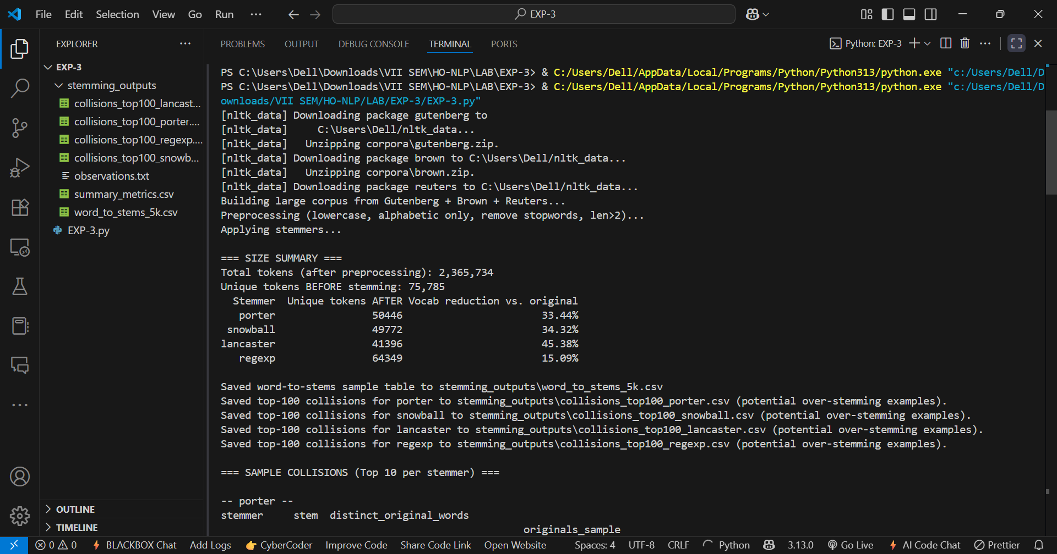

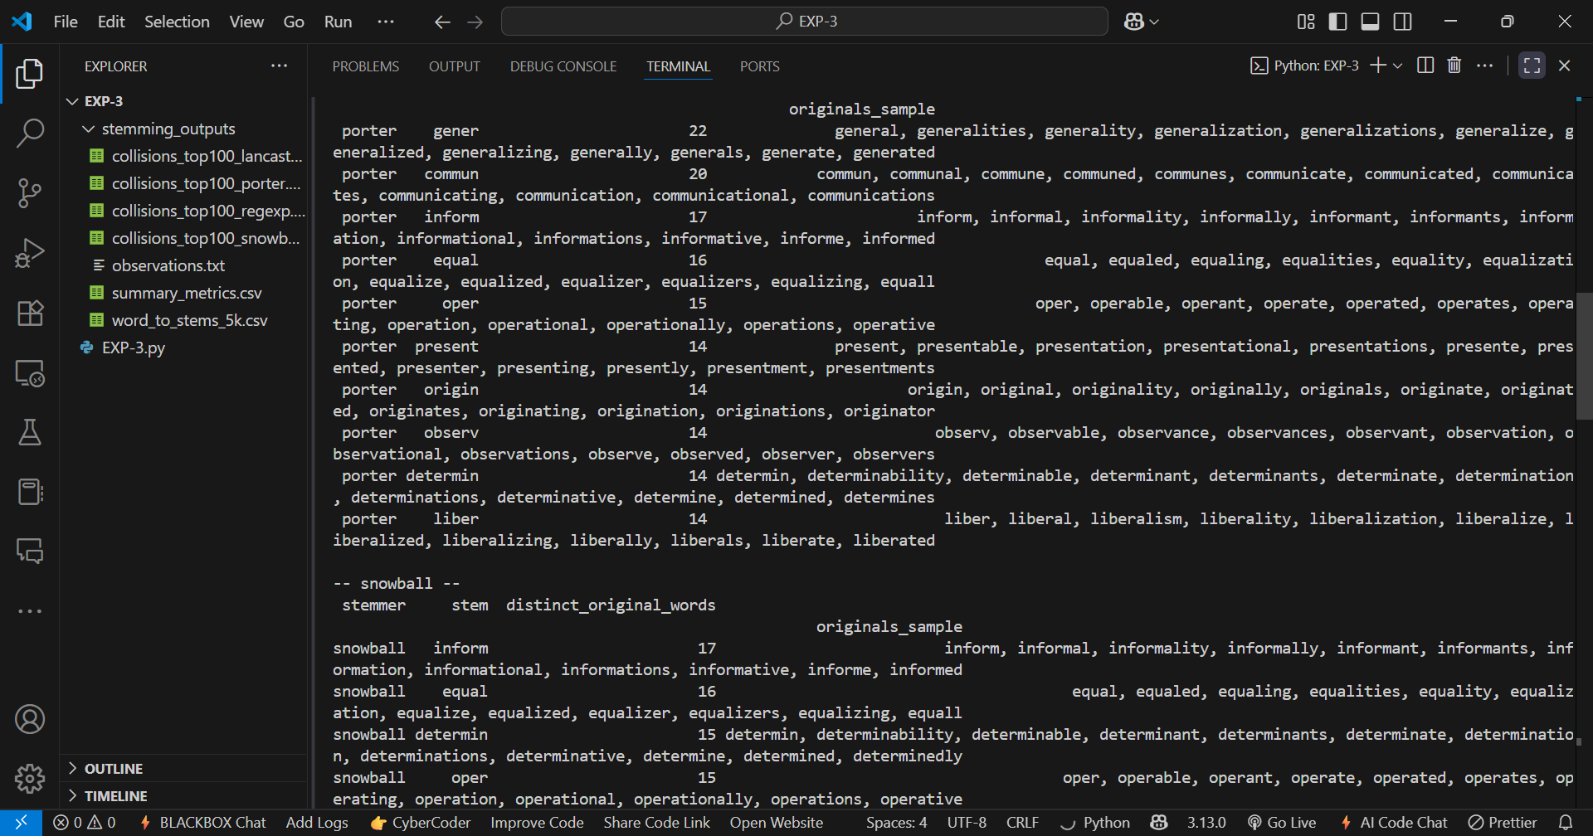

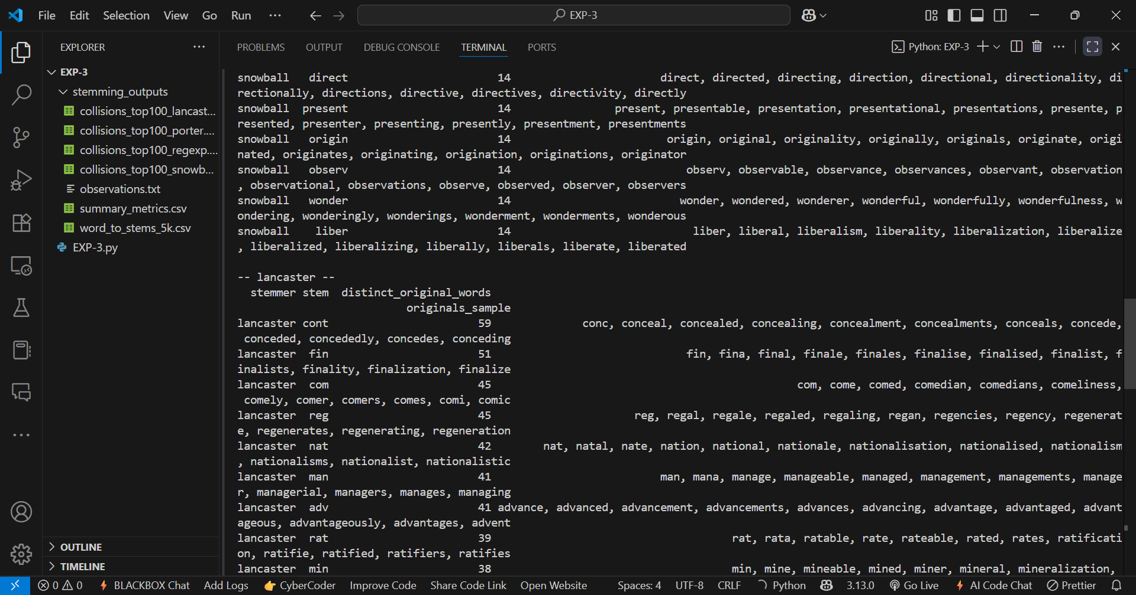

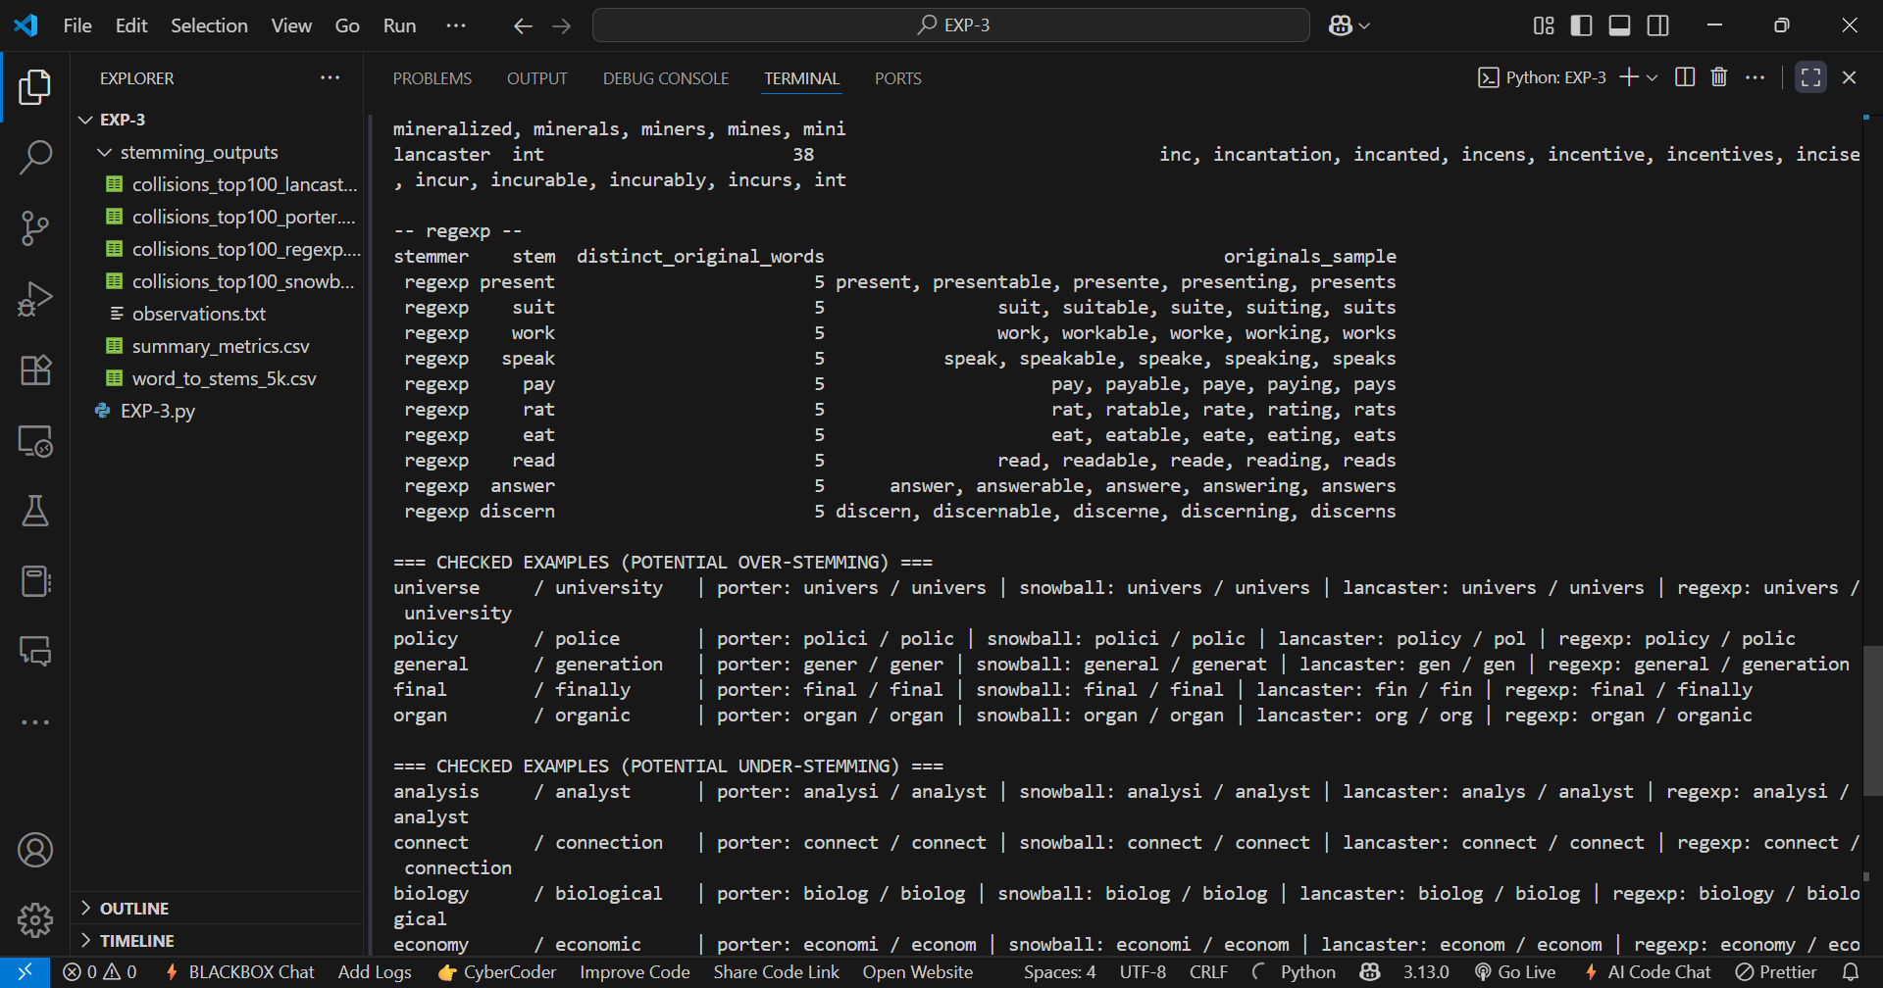

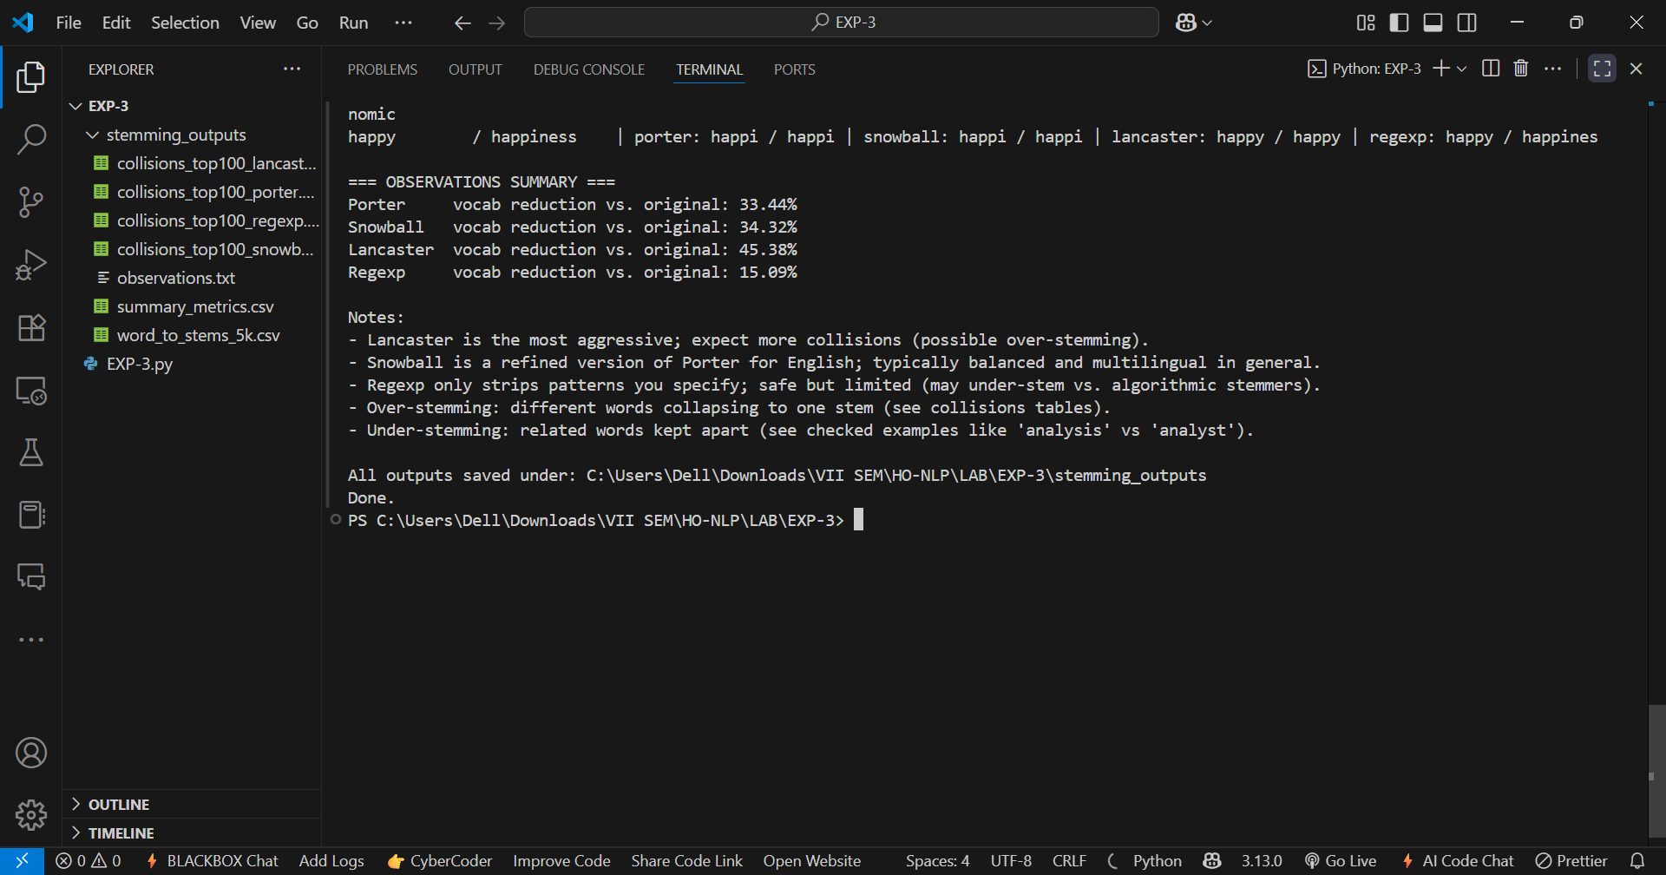

______________________________________________________________________________

Post Lab Question-Answers:
- Explain Under-Stemming and Over-Stemming errors with the help of suitable examples.
Ans: i) Under-Stemming Error
- This occurs when the stemmer fails to reduce related words to the same root form — it “under-stems” and keeps them separate.
- Example:
  - Words: connect, connected, connection
If the stemmer outputs:
connect → connect
connected → connect
connection → connection (❌ different stem)
  - Here, connection is not reduced to connect, so related words are treated as different.
ii) Over-Stemming Error
- This occurs when the stemmer reduces unrelated words to the same root form — it “over-stems” and merges them incorrectly.
- Example:
  - Words: universe, university
If the stemmer outputs:
universe → univers
university → univers (❌ unrelated words now have same stem)
  - Here, two different concepts are mistakenly grouped as the same.
______________________________________________________________________________

Outcomes: CO2 – Comprehend Words and Word Forms in NLP
______________________________________________________________________________

Conclusion (based on the Results and Outcomes achieved):
In conclusion, the experiment demonstrated that stemming is a crucial step in the NLP pipeline for reducing words to their base or root form, thereby simplifying text analysis and reducing vocabulary size. The results showed that each stemmer has its own strengths and weaknesses — Porter is fast and simple, Snowball is more versatile with better accuracy and multilingual support, Lancaster is highly aggressive but prone to over-stemming, and Regexp offers flexibility through customizable rules. The effectiveness of a stemmer depends on the application requirements, as over-stemming can merge unrelated words while under-stemming can fail to unify related terms. Choosing the right stemmer is therefore essential for balancing accuracy and dimensionality reduction in NLP tasks.
______________________________________________________________________________

References:
Books/ Journals/ Websites:
- Allen James, Natural Language Understanding, Benjamin Cumming, Second Edition, 1995
- Jurafsky, Dan and Martin, James, Speech and Language Processing, Prentice Hall, 2008
- Palash Goyal, Karan Jain, Sumit Pandey,Deep Learning for Natural Language Processing: Creating Neural Networks with Python, Apress, 2018
______________________________________________________________________________

